Scorebored QA

### Main page

~~Should be able to browse all boards! Should also be able to search for a board by name.~~

Board components should be editable by the creator—including scoring system level names—individual line items should be editable until someone else votes them up or down, then their value should be fixed.

Ty: Scoring level names are configurable when you set up a board. Other stuff is too much to do now

Line items should be editable (or at least delete-able) in the event of typos UNTIL someone comments on them.   
Done. There is now a delete button if you created the item and there were no comments. Unfortunately, it doesn’t check if comments have been made since you loaded the board

* ~~HOME (title: Scorebored)~~
* ~~SIGN UP (title: Register to Score)~~
  + ~~Shout your two cents from the mountain tops! Be frivolous or serious in asking any question your heart desires. Let’s just get you signed up first.~~
  + ~~We promise we won't use your email for anything evil or willingly let anyone else do it. We just need to verify identities to filter out spammers. You're not a spammer, are you?~~
* ~~HOW TO (title: How to score)~~
  + ~~Let’s get started!~~
  + ~~First things first, before you can create your own board you need to~~ [~~signup~~](http://www.scorebored.net/Signup.aspx)~~.~~
* ~~All ready to go? Great! Add line items to any board. Decide how important the item in question is on a scale of 1-5.~~
* ~~Disagree? You can vote other people’s items “up” or “down’ to add your voice to the discussion and affect the overall score. You can even make comments to justify your reasoning, if you want to.~~
* ~~Most importantly, discover the truths to life's mysteries and make life altering decisions based on the capricious whims and insights of other internet users. What could go wrong!?~~
* NEW (title: Looking to score?)
  + Want to set up a new board? Just log in?
  + Otherwise I like the text in this section
* Embed: should go here:
  + 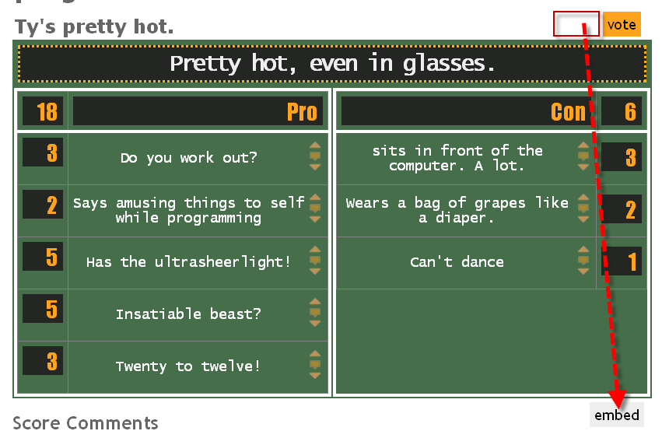

Main page text:

This needs to look better. Maybe it can look something like this:

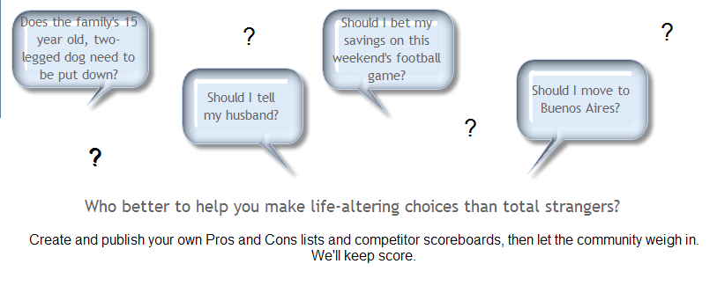

I’ve changed some of the content to better reflect what a scoreboard might be asking

## Should be “Pros” and “Cons” not pro/con

## ~~Vote Button~~

~~On main page, should read “Vote!”~~

## To add a new item

~~When clicking on the vote button and the window opens, should read:~~

~~Affect the overall score by adding your voice to the debate. (50 characters max)~~

~~Overall, how important is this item to you on a scale of 1-5 (1=noteworthy, 5=critical)? We’re on the honor system here. C’mon, don’t be “that” person who always votes their own items as a “5”.~~

~~Vote “Pro”! Vote “Con”!   
I changed my mind.~~

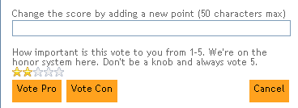

~~Should Highlight the parent cell while adding a comment.~~

## ~~Voting Up and Down~~

~~Tooltip:~~

* ~~Up arrow: should read, “I Agree” - if agree is clicked then points are added~~
* ~~Down arrow: read, “I Disagree” - if disagree is clicked then points are deducted~~

~~When voting up window should read:~~

**~~Agree:~~**

~~So you agree! That’s great. Your vote will change the overall score. Now’s your chance to tell us why, if you’re so inclined.~~

~~[comment box]~~

**~~Disagree:~~**

~~So you disagree! That’s fine, you’re certainly entitled to your own opinion. Your vote will change the overall score. Now’s your chance to tell us why you feel that way, if you’re so inclined.~~

~~[comment box]~~

**~~Comment:~~**

~~Comment are automatic with the vote up or vote down. Comments should also have the ability for other people to comment ON the comments.~~can delete and replay now: test it

## Functionality problems:

Comments boxes not working correctly:

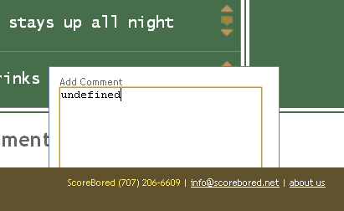

Can actually vote (any number of stars) on an empty field. There should be a minimum character amount. Should we have a mod review and accept submissions before posting to ensure validity? Maybe that’s something we could implement later.

The “tools” and “clear” links/buttons don’t work:

